The CDC’s Adverse Childhood Experiences Study

Got Your ACE Score?

What’s Your ACE Score?
There are 10 types of childhood trauma measured in the ACE Study. Five are personal — physical abuse, verbal abuse, sexual abuse, physical neglect, and emotional neglect. Five are related to other family members: a parent who’s an alcoholic, a mother who’s a victim of domestic violence, a family member in jail, a family member diagnosed with a mental illness, and the disappearance of a parent through divorce, death or abandonment. Each type of trauma counts as one. So a person who’s been physically abused, with one alcoholic parent, and a mother who was beaten up has an ACE score of three.

Now that you’ve got your ACE score, what does it mean?
First….a tiny bit of background to help you figure this out…..(if you want the back story about the fascinating origins of the ACE Study, read The Adverse Childhood Experiences Study — the largest, most important public health study you never heard of — began in an obesity clinic.)
The CDC’s Adverse Childhood Experiences Study (ACE Study) uncovered a stunning link between childhood trauma and the chronic diseases people develop as adults, as well as social and emotional problems. This includes heart disease, lung cancer, diabetes and many autoimmune diseases, as well as depression, violence, being a victim of violence, and suicide.
The first research results were published in 1998, followed by 57 other publications through 2011. They showed that:
- childhood trauma was very common, even in employed white middle-class, college-educated people with great health insurance;
- there was a direct link between childhood trauma and adult onset of chronic disease, as well as depression, suicide, being violent and a victim of violence;
- more types of trauma increased the risk of health, social and emotional problems.
- people usually experience more than one type of trauma – rarely is it only sex abuse or only verbal abuse.
A whopping two thirds of the 17,000 people in the ACE Study had an ACE score of at least one — 87 percent of those had more than one. Eighteen states have done their own ACE surveys; their results are similar to the CDC’s ACE Study.
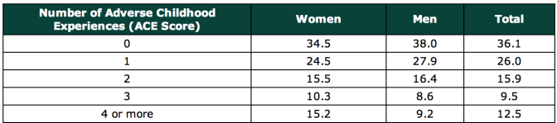
The study’s researchers came up with an ACE score to explain a person’s risk for chronic disease. Think of it as a cholesterol score for childhood toxic stress. You get one point for each type of trauma. The higher your ACE score, the higher your risk of health and social problems. (Of course, other types of trauma exist that could contribute to an ACE score, so it is conceivable that people could have ACE scores higher than 10; however, the ACE Study measured only 10 types.)
As your ACE score increases, so does the risk of disease, social and emotional problems. With an ACE score of 4 or more, things start getting serious. The likelihood of chronic pulmonary lung disease increases 390 percent; hepatitis, 240 percent; depression 460 percent; suicide, 1,220 percent.
(By the way, lest you think that the ACE Study was yet another involving inner-city poor people of color, take note: The study’s participants were 17,000 mostly white, middle and upper-middle class college-educated San Diegans with good jobs and great health care – they all belonged to the Kaiser Permanente health maintenance organization.)
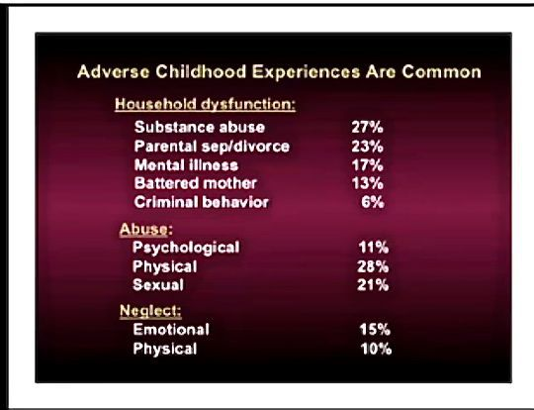
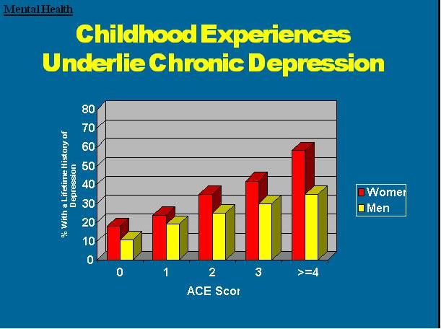
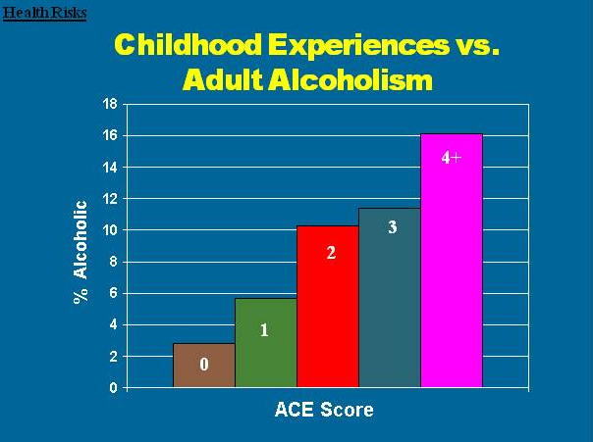
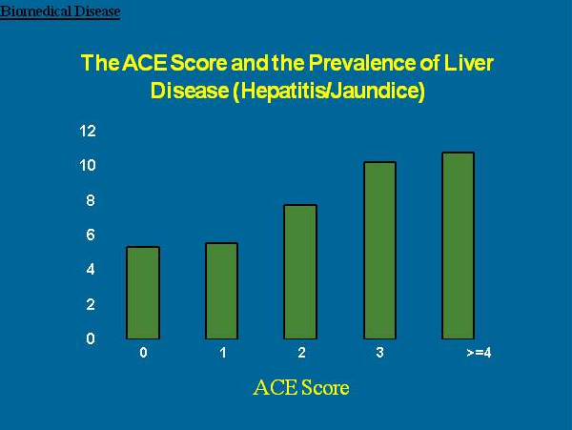
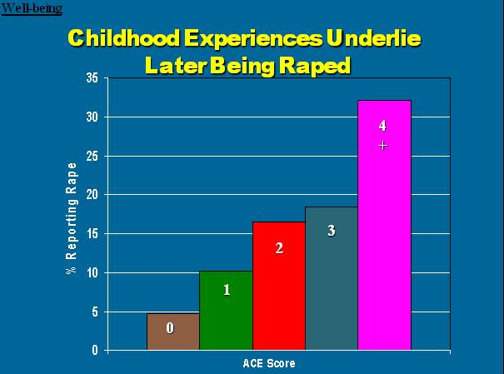
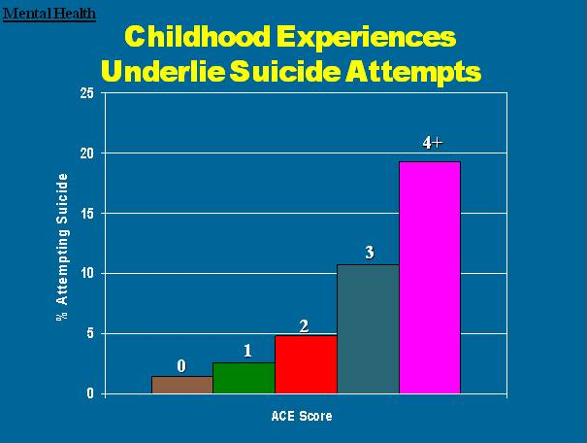
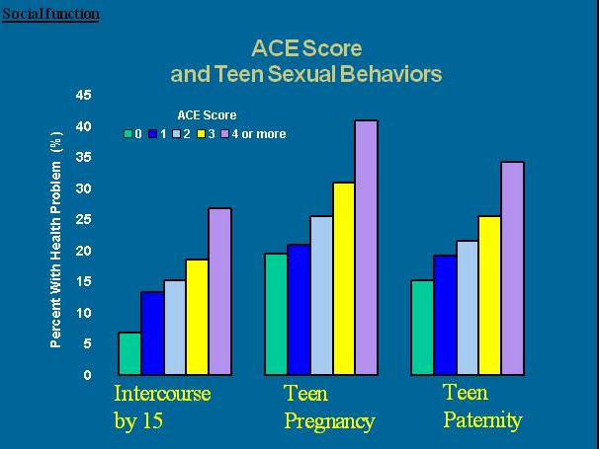
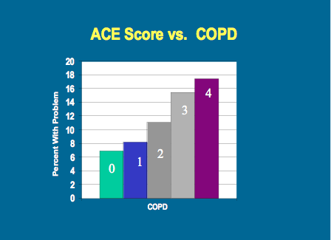

What causes this?
At the same time that the ACE Study was being done, parallel research on kids’ brains found that toxic stress physically damages a child’s developing brain. This was determined by a group of neuroscientists and pediatricians, including neuroscientist Martin Teicher and pediatrician Jack Shonkoff, both at Harvard University, neuroscientist Bruce McEwen at Rockefeller University, and pediatrician Bruce Perry at the Child Trauma Academy.
When children are overloaded with stress hormones, they’re in flight, fright or freeze mode. They can’t learn in school. They often have difficulty trusting adults or developing healthy relationships with peers (i.e., they become loners). To relieve their anxiety, depression, guilt, shame, and/or inability to focus, they turn to easily available biochemical solutions — nicotine, alcohol, marijuana, methamphetamine — or activities in which they can escape their problems — high-risk sports, proliferation of sex partners, and work/over-achievement. (e.g. Nicotine reduces anger, increases focus and relieves depression. Alcohol relieves stress.)
Using drugs or overeating or engaging in risky behavior leads to consequences as a direct result of this behavior. For example, smoking can lead to COPD (chronic obstructive pulmonary disease) or lung cancer. Overeating can lead to obesity and diabetes. In addition, there is increasing research that shows that severe and chronic stress leads to bodily systems producing an inflammatory response that leads to disease.
For more information about that aspect, check out the interactive graphic COLEVA — Consequences of lifetime exposure to violence and abuse. Here’s a screen-grab of the home page of that site to give you an idea of how extensive the research is.
For more information about the ACE Study, check out the CDC’s ACE Study site.

What are the health effects of toxic stress?
Chronic toxic stress—living in a red alert mode for months or years—can also damage our bodies. In a red alert state, the body pumps out adrenaline and cortisol continuously. Over time, the constant presence of adrenaline and cortisol keep blood pressure high, which weakens the heart and circulatory system. They also keep glucose levels high to provide enough energy for the heart and muscles to act quickly; this can lead to type 2 diabetes. Too much adrenaline and cortisol can also increase cholesterol.
Too much cortisol can lead to osteoporosis, arthritis, gastrointestinal disease, depression, anorexia nervosa, Cushing’s syndrome, hyperthyroidism and the shrinkage of lymph nodes, leading to the inability to ward off infections.
If the red alert system is always on, eventually the adrenal glands give out, and the body can’t produce enough cortisol to keep up with the demand. This may cause the immune system to attack parts of the body, which can lead to lupus, multiple sclerosis, rheumatoid arthritis, and fibromyalgia.
Cortisol is also extremely important in maintaining the body’s appropriate inflammation response. In a normal response to a bee sting or infection, the body rushes antibodies, white blood cells and other cell fighters to the site and the tissues swell while the battle rages. But too much swelling damages tissue. Cortisol controls this fine balance. So without the mediating effects of cortisol, the inflammatory response runs amok and can cause a host of diseases.
If you’re chronically stressed and then experience an additional traumatic event, your body will have trouble returning to a normal state. Over time, you will become more sensitive to trauma or stress, developing a hair-trigger response to events that other people shrug off.
Biomedical researchers say that childhood trauma is biologically embedded in our bodies: Children with adverse childhood experiences and adults who have experienced childhood trauma may respond more quickly and strongly to events or conversations that would not affect those with no ACEs, and have higher levels of indicators for inflammation than those who have not suffered childhood trauma. This wear and tear on the body is the main reason why the lifespan of people with an ACE score of six or higher is likely to be shortened by 20 years.
Resources:
Scared Sick: The Role of Childhood Trauma in Adult Disease by Robin Karr-Morse with Meredith S. Wiley
Biologial Embedding of Early Social Adversity, Proceedings of the National Academy of Sciences, 2012
PubMed childhood adversity research publications
Childhood Disrupted: How Your Biography Becomes Your Biology and How You Can Heal, by Donna Jackson Nakazawa
There is well documented research on how individuals’ brains and bodies become healthier through mindfulness practices, exercise, good nutrition, adequate sleep, and healthy social interactions.
Research on families shows that interventions — such as Nurse-Family Partnership, Healthy Steps, and Child First — can improve the lives of parents and children. Evidence-based parenting practices (Incredible Years, Triple P Parenting, etc.), increase the health of parents and children.
Research on communities and systems is emerging, but early data, especially from schools and juvenile detention centers, is showing promise.
Here’s a good article that weaves the unified science of human development together: Scars That Don’t Fade, from Massachusetts General Hospital’s Proto Magazine.
Resources:
Community Resilience Cookbook (nine case studies of cities and states that are integrating ACEs research)
Roadmap to Resilience infographic and the text that describes the steps along the roadmap that communities take to become trauma-informed to to build resilience.
Resources:
SAMHSA overview of what trauma-informed is and isn’t
National Center for Trauma-Informed Care
SAMHSA’s Concept of Trauma and Guidance for a Trauma-Informed Approach — Introduces a concept of trauma and offers a framework for how an organization, system, or service sector can become trauma-informed. Includes a definition of trauma (the three “E’s”), a definition of a trauma-informed approach (the four “R’s”), 6 key principles, and 10 implementation domains.

All resources:
CDC ACE Study site
Wikipedia — Adverse Childhood Experiences Study
The 10 ACE Questions (and 14 resilience survey questions)
Harvard University Center on the Developing Child (neurobiology of toxic stress)
Alberta Family Wellness Initiative (Canada)
ACEsTooHigh.com – news site covering ACEs research and practices
ACEsConnection.com –social network (with 11,000+ members)
WhatIsEpigenetics.com – news site covering epigenetics
Epigenetics — Explainers and backgrounders about epigenetics
National Center for Trauma-Informed Care
Community Resilience Cookbook (nine case studies of cities and states that are integrating ACEs research)
SAMHSA’s Concept of Trauma and Guidance for a Trauma-Informed Approach — Introduces a concept of trauma and offers a framework for how an organization, system, or service sector can become trauma-informed. Includes a definition of trauma (the three “E’s”), a definition of a trauma-informed approach (the four “R’s”), 6 key principles, and 10 implementation domains.
Videos:
ACE Study video (three minute trailer)
Video: Toxic Stress Derails Healthy Development (2 min)
How childhood trauma affects health across a lifetime (16-minute TED Talk by Dr. Nadine Burke Harris)
Books:
Scared Sick: The Role of Childhood Trauma in Adult Disease by Robin Karr-Morse with Meredith S. Wiley
The Last Best Cure: My Quest to Awaken the Healing Parts of My Brain and Get Back My Body, My Joy, and My Life, by Donna Jackson Nakazawa
Childhood Disrupted: How Your Biography Becomes Your Biology and How You Can Heal, by Donna Jackson Nakazawa
Documentaries:
Paper Tigers — What does it mean to be a trauma-informed school? And how do you educate teens whose childhood experiences have left them with a brain and body ill-suited to learn? This film follows six students through a year in America’s first trauma-informed high school.
Resilience — Resilience chronicles how trailblazers in pediatrics, education, and social welfare are using cutting-edge science and field-tested therapies to protect children from the insidious effects of toxic stress.
CAREgivers — How is the professional care provider affected emotionally and physically, and who helps him or her?

Child abuse prevention
- Darkness 2 Light
- EndHittingUSA
- Parents Anonymous
- Prevent Child Abuse America
- Stop It Now!

