RACHEL BRESKMAN, MEd, CAC
The Wyncote House, Suite A1
25 Washington Lane
Wyncote, PA 19095
215-886-5611
PA License No. PS-007659-L
SURVIVORS BECOMING
THRIVERS:
THERAPY GROUP FOR SURVIVORS OF
SEXUAL ABUSE
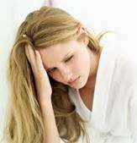
- Join fellow survivors in exploring your path to healing in the CONFIDENTIAL, safe environment of ongoing group
- Learn tools for coping with painful emotions and posttraumatic stress
- Receive support and validation & learn you are not alone!
- Improve self-esteem and self-acceptance

For free initial screening, call Rachel Breskman, MEd, CAC,
Licensed Psychologist and trauma and sexual abuse specialist of 28 years
215-886-5611
Thursday evenings 7-8:30 pm
Fees: $50 with some insurance coverage

